WEEK 3 - SCANNER

**NOTES: List of modified files**

scanner.c charcode.c

error.c charcode.h

error.h token.c

token.h

**A. Identifier:**

1. The first letter of an identifier should be either a letter or an underscore.

🡪 (line 1 – column 9)

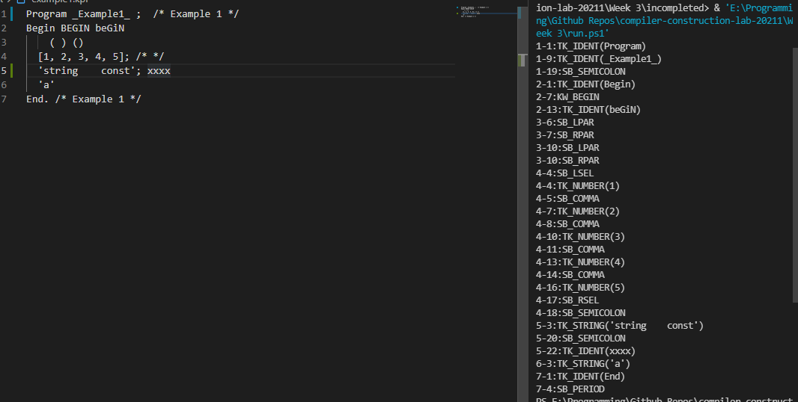

2. You cannot use keywords as identifiers.  
🡪 Don’t have to change anything. We have already named KW and TK_IDENT differently

3. There is no rule on how long an identifier can be. However, only 15 characters are significant.

🡪 (line 1 – column 9)

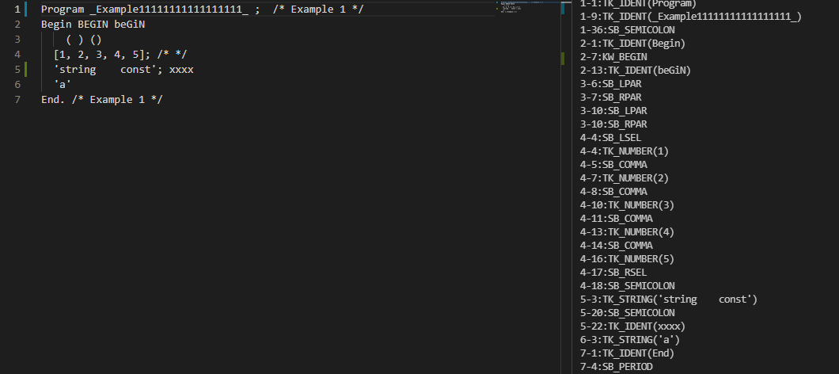

4. Identifiers are case-sensitive. 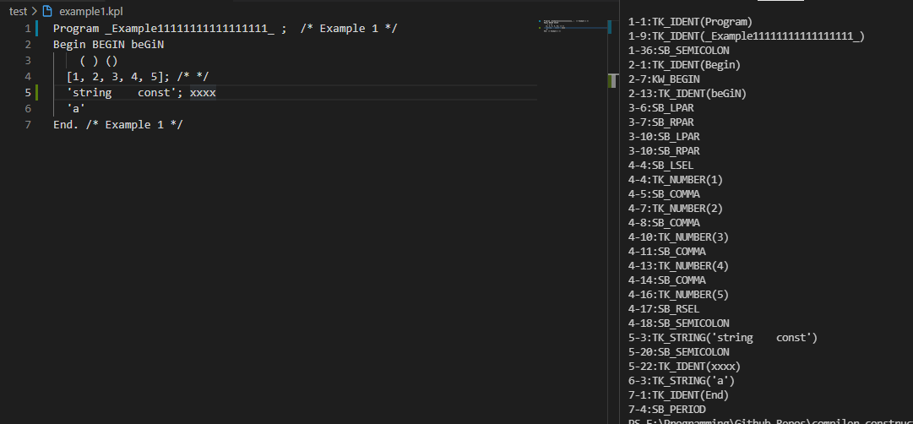

🡪 If we don’t write exactly “BEGIN”, the program would consider the token as the TK_IDENT

**B. Keywords:**

Keywords are case-insensitive

🡪 Don’t have to change anything

**C. Comments:**

Multi-line Comments : between /* and */

🡪 The program skipped line 5, 6

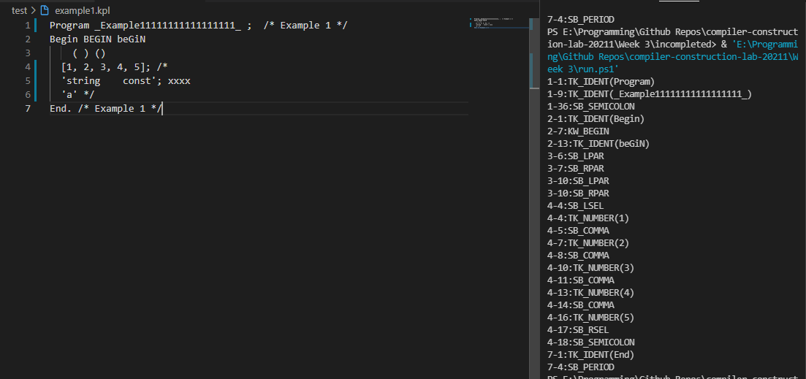

**D. Special Symbols:**

Indexing expression enclosed by [ and ] instead of (. and .)

🡪 The array of line 4

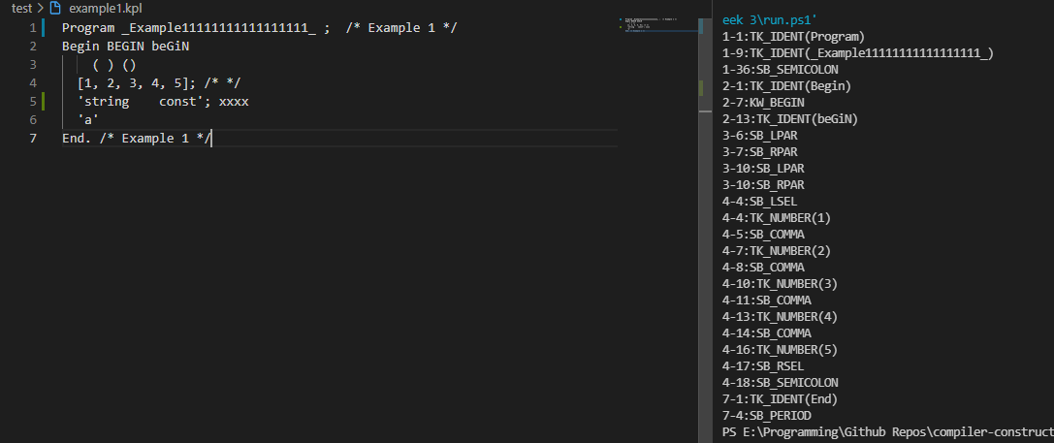

**E. Character/String constants:**

String constants are allowed in KPL. A string constant can contain a sequence of printable symbols, length not exceeding 255, enclosed in single quotes. A single quote is written as ''''

*1. Normal case*

🡪 (line 5 - column 3)

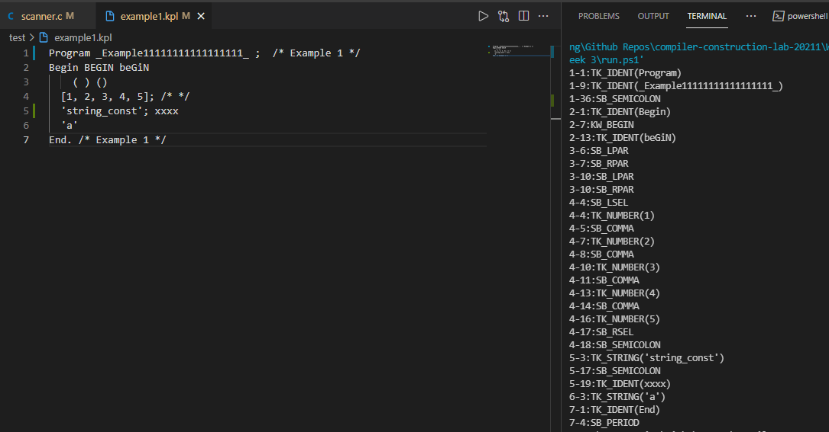

*2. Strings including spaces*

🡪 (line 5 - column 3)

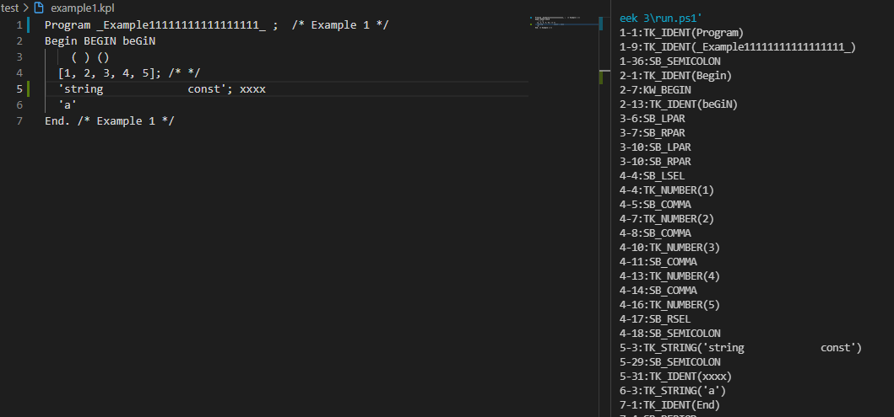

*3. Strings including multiple single quotes*

🡪 (line 5 - column 3)

